Practical-3

Aim – 1. create a table student (roll no., name, dept) and write the query to alter and update the table.

SQL> create table student (rollno int, name varchar (50), dept varchar (10));

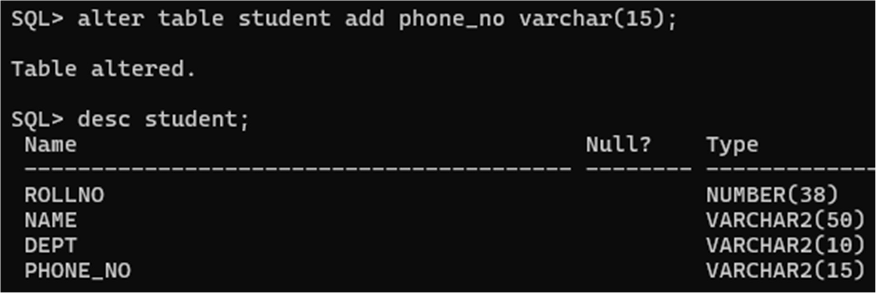

2.Add another column to add phone no.

SQL> alter table student add phone_no varchar (15);



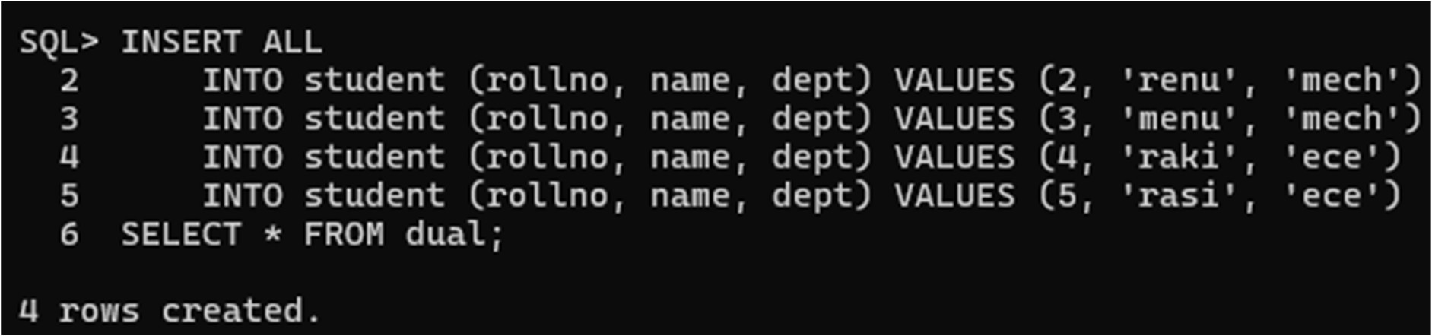3.insert the 4 rows in the table.

4. delete rows with dept mech.

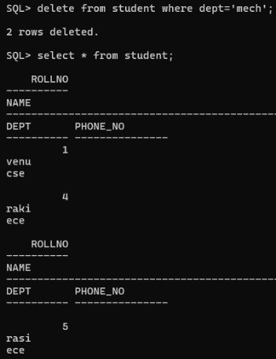SQL> delete from student where dept=’mech’;

5. truncate table.

SQL> truncate table student;

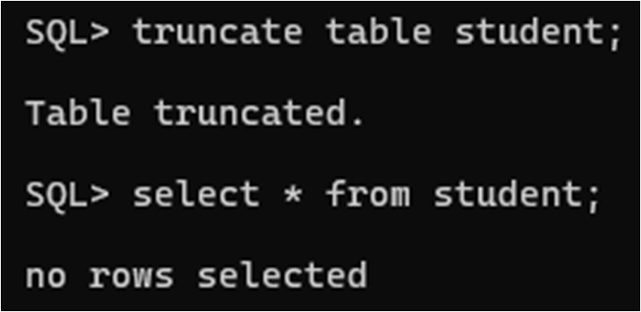

6. Add 10 new records to the table.

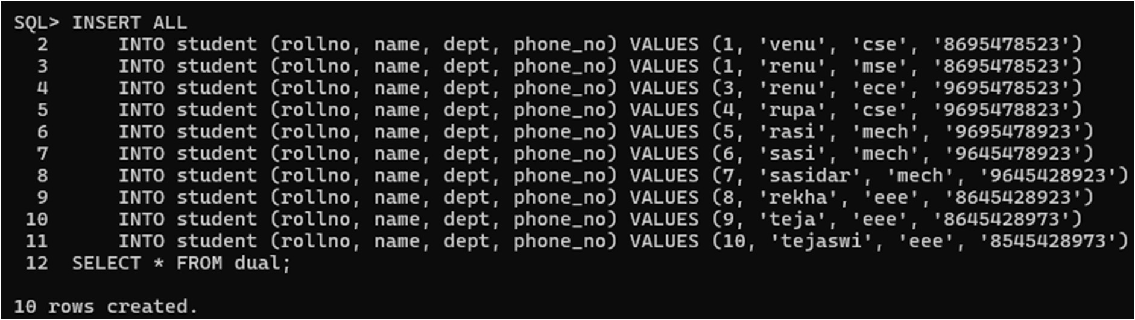

7.show the table.

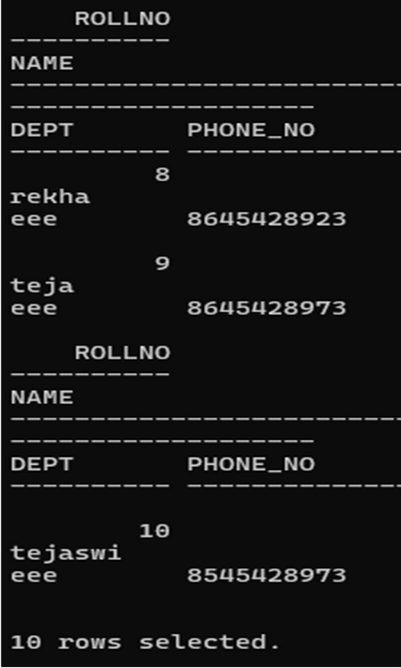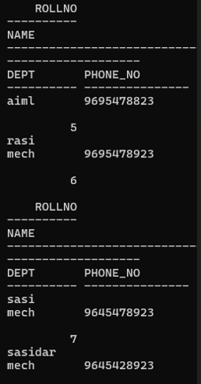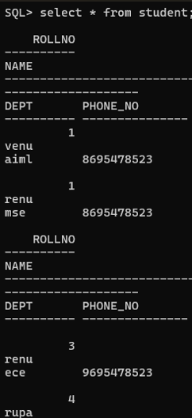SQL> select * from student;

8. Update the department of cse student to aiml.

SQL> update student set dept =’cse’ where dept =’aiml’;

SQL>select * from student;

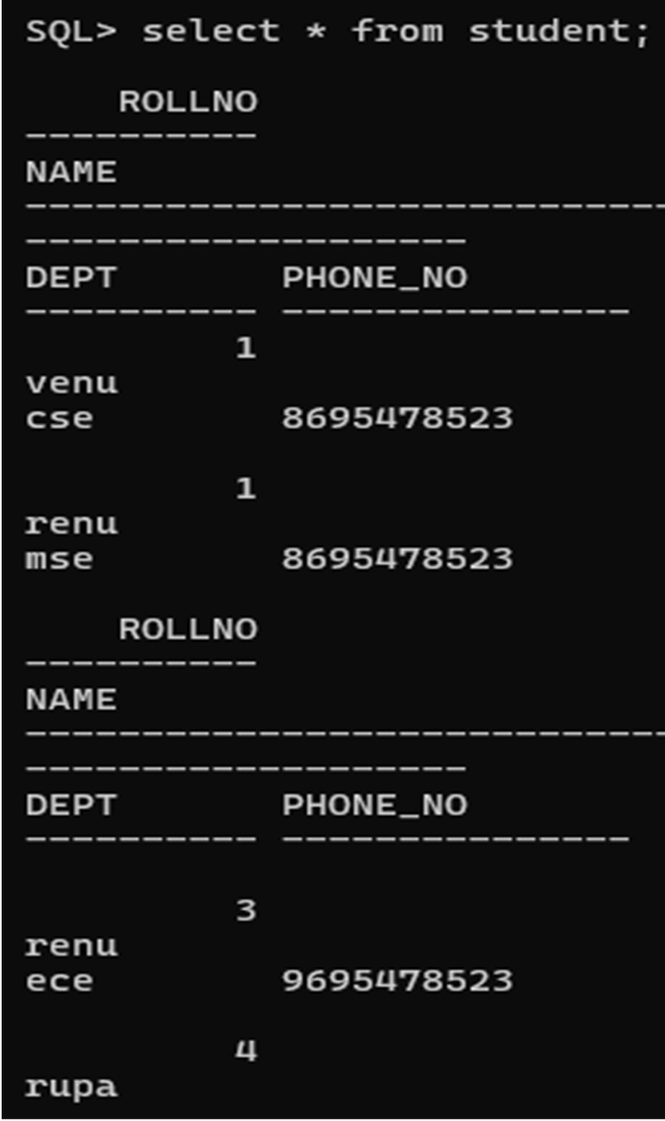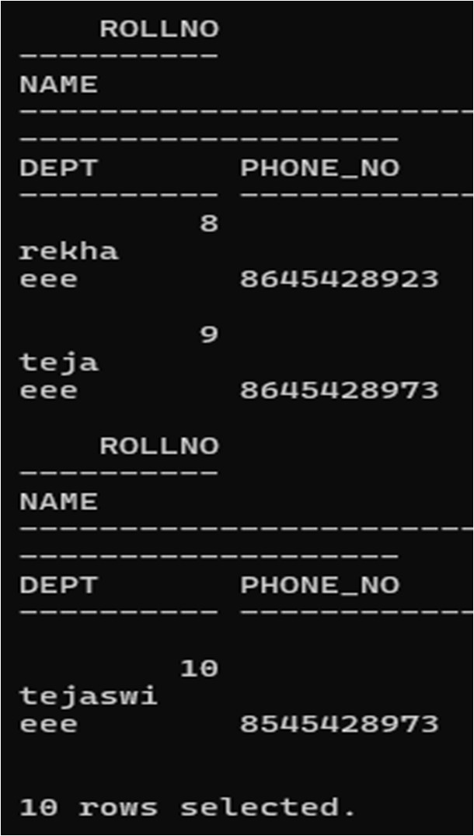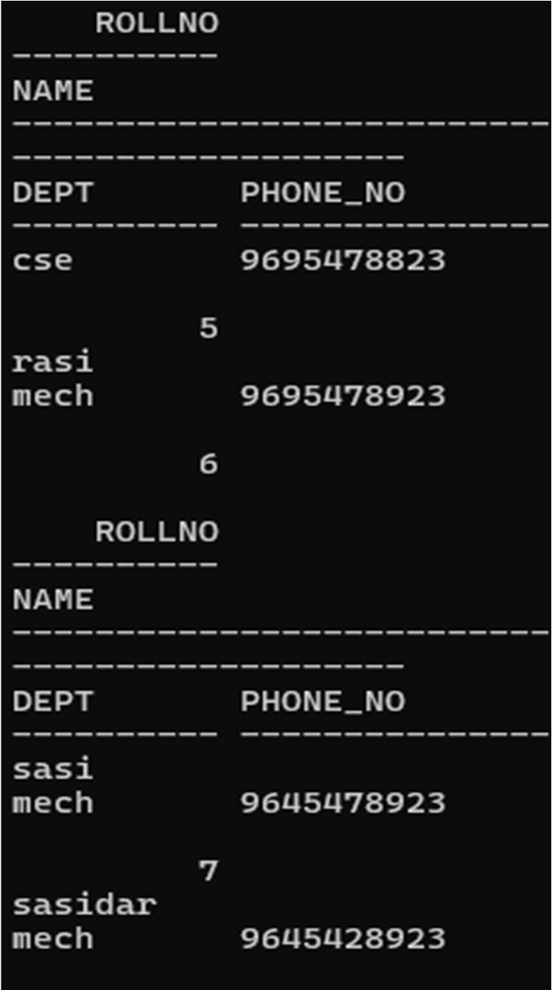

9.delete column dept.

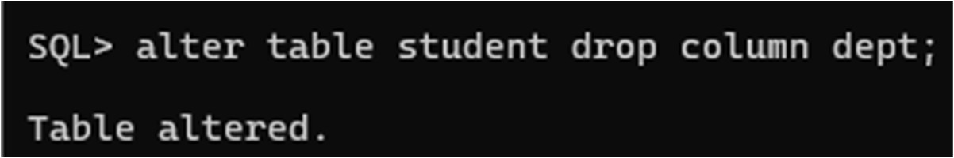SQL> Alter table student drop column dept;

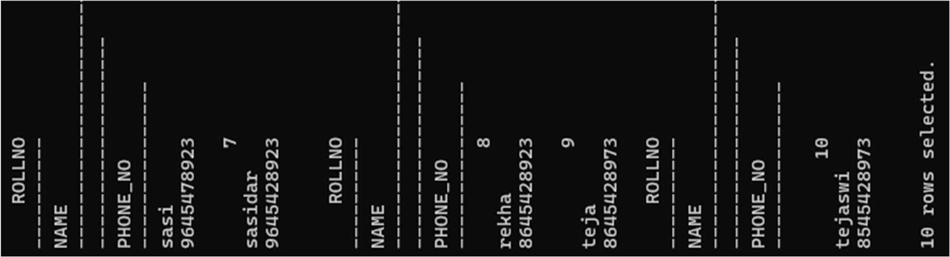  
SQL> select *from student;

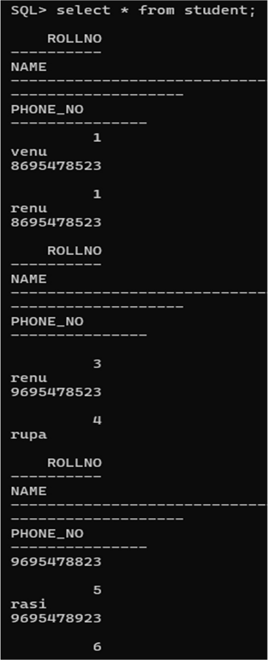

10. drop table.

SQL> drop table student;

